Infosys Springboard Virtual Internship 6.0 Completion Report

Team Details

Beach Number: 08
Start data: 22-NOV-25
Names:

S.No. | NAME
1 | Keerthana Sanivada
2 | Thanuja Vanjarapu
3 | Sri Anjhanee Kunchanapalli
4 | Hemanthraj D
5 | Deepak P

Internship Duration: 8 Weeks

- Project Title

SMART HOME ENERGY MANAGEMENT SYSTEM (SHEMS)

- Project Objective

The Smart Home Energy Management System (SHEMS) is a web-based application designed to monitor, manage, and optimize electricity usage within a smart home environment. With the increasing demand for energy efficiency and cost reduction, SHEMS provides homeowners with an intelligent platform to track appliance-level power consumption, identify energy wastage, and implement automation for better control.
The system aims to bridge the gap between traditional electricity monitoring methods and modern smart home requirements. Instead of relying only on monthly electricity bills, SHEMS offers real-time insights, device management capabilities, and predictive analytics that help users make informed decisions to reduce energy consumption. The application is developed using Java Spring Boot, follows a layered architecture, and integrates secure authentication, device control, and scalable module-based expansion.

- Project Description in Detail

Smart homes today consist of multiple electrical appliances that operate continuously, often leading to unnecessary power wastage and high electricity costs. In conventional households, users lack visibility into which devices consume the most energy, and there is no intelligent mechanism to automate or optimize usage. This results in inefficient consumption patterns, unexpected billing, and potential safety concerns such as overheating or abnormal power draw.
To address these challenges, the Smart Home Energy Management System (SHEMS) provides a structured and intelligent solution that enables users to monitor energy usage in real time, manage appliances digitally, and implement smart automation rules. The system is divided into multiple functional modules to ensure scalability and maintainability.
As part of the current implementation, Module 1 (Authentication & Role Management) ensures secure system access through user login, role-based authorization, and session handling. Module 2 (Smart Device Management) enables users to add, view, update, and control home appliances through a centralized dashboard. These foundational modules establish the core security and device interaction layer of the project.
The system follows a 4-layer architecture consisting of Presentation, Service, Repository, and Model layers, ensuring clean separation of concerns and ease of future enhancements. Upcoming modules such as real-time energy tracking, analytics dashboards, scheduling automation, and alert notifications will further extend the system into a complete smart energy optimization platform.
Overall, SHEMS transforms traditional energy consumption into a transparent, manageable, and optimized smart-home experience, helping users reduce electricity costs, improve safety, and adopt energy-efficient living practices.

- Timeline Overview

Week | Activities Planned | Activities Completed
Week-1 | Project introduction, technology selection discussion, project statement, expected outcomes, milestones planning, system architecture, database schema, deployment diagram, component diagram, identification of Modules 1 to 6 and their main classes. | Conducted project kickoff meeting, finalized project scope and objectives, selected technology stack, designed system architecture and database schema, prepared deployment and component diagrams, identified core modules and performed a deep dive into Module 1 classes.
Week-2 | Defining system rules for all modules including authentication rules, smart device management rules, real-time data handling rules, analytics dashboard rules, scheduling and automation rules, notification rules, and database schema constraints. Implementation and presentation of Module 1 (Authentication & User Access). | Finalized login, access control, and role-based rules for Module 1; defined device registration and validation rules for Module 2; established data integrity and energy storage rules for Module 3; dashboard accuracy and interaction rules for Module 4; scheduling, automation, and notification rules; discussed failure scenarios and system limitations. Presented MIlestone 1 (Authentication & User Access).
Week-3 | Designing class skeletons for Modules 1 to 6, defining attributes, methods, and pseudocode logic; identifying possible problems and solutions for each module. | Prepared detailed pseudocodes for all major classes across modules, discussed class-level logic, analyzed module-wise problems, and proposed solutions for handling errors, failures, and edge cases.
Week-4 | Scenario-based understanding and Java coding demonstrations to understand module logic and real-time behavior. Implementation and conceptual presentation of Module 2(Smart Device Management). | Solved multiple scenario-based Java problems, demonstrated logic using stacks, rules, and automation flows, and gained practical understanding of how modules interact during real-time execution.Delivered Milestone2 (Smart Device Management)
Week-5 | Group-wise activities and discussions to analyze real-world failure cases and collaborative problem-solving. | Teams were divided and group activities were conducted; each group analyzed specific system failures and proposed solutions, improving understanding of real-world smart home challenges.
Week-6 | Implementation and conceptual presentation of Module 3 (Real-Time Energy Monitoring & Alerts). Implementation of Module 1 (Authentication & User Access) as Team | Presented Milestone 3 explaining real-time data tracking, energy usage rules, alerts, and analytics concepts using diagrams and scenarios. Successfully implemented Module 1, covering authentication concepts and design as a Team.
Week-7 | Testing of Module 1 (Authentication & User Access) along with database integration. Implementation of Module 2 (Smart Device Management) and integration with Module 1. | Tested login and role-based access rules, verified database operations using MySQL. Implemented device registration and control features, connected Module 2 with authentication flow, tested device operations, and presented Module1, 2 Working.
Week-8 | Combined implementation presentation of Module 1 and Module 2 as a team. | Delivered Milestone 4 demonstrating working implementation of authentication and device management modules with database integration and application flow. Prepared README documentation, summarized commits and milestones

- Key Milestones

The development of the Smart Home Energy Management System (SHEMS) was carried out in a phased and milestone-driven manner to ensure systematic progress, architectural clarity, and secure feature implementation. Each milestone marked a significant advancement in functionality, stability, and readiness of the system.

Milestone | Description | Status
Project Initiation & Requirement Analysis | Finalized project objectives, identified system scope, studied smart home energy management concepts, and defined user roles and access policies. | Completed
System Architecture Design | Designed layered architecture including Controller, Service, Repository, and Entity layers. Established separation of concerns and security boundaries. | Completed
Authentication & Authorization Module | Implemented secure user registration and login with role-based access control using Spring Security. Enforced single active admin session and prevented unauthorized access. | Completed
Smart Device Management Module | Developed device registration, ON/OFF control, and device status monitoring with strict role-based permissions. Linked devices securely to authenticated users. | Completed
Backend–Frontend Integration | Integrated backend APIs with frontend using Thymeleaf to enable secure user interaction with device controls and dashboards. | Completed
Testing & Validation | Performed functional testing of authentication flows, role permissions, and device control operations using Postman and application logs. | Completed
Documentation & Future Planning | Prepared detailed project documentation and outlined future enhancements such as energy analytics, automation rules, and alert systems. | Completed

- Project Execution Details

The Smart Home Energy Management System (SHEMS) was developed using a structured backend-focused development approach over multiple implementation phases. The execution began with requirement analysis and system design, followed by secure module development and integration.

Initially, project objectives were defined with a strong emphasis on security, role-based access control, and centralized device management. Core technologies such as Java, Spring Boot, Spring Security, Spring Data JPA, and MySQL were selected to ensure scalability, maintainability, and industry relevance. A layered architecture was adopted to clearly separate responsibilities across controllers, services, repositories, and entities.

The first major implementation phase focused on the Authentication and User Access module. Secure user registration and login mechanisms were implemented using Spring Security, with encrypted password handling and role-based authorization. User roles such as Admin, Family Member, and Guest were configured to restrict access to sensitive operations. Additional controls, including prevention of shared logins and enforcement of a single active admin session, were incorporated to enhance system accountability and security.

Following authentication, the Smart Device Management module was developed. This module enabled authenticated users to register smart devices, monitor their operational status, and control devices through centralized APIs. Device actions such as ON/OFF toggling were protected through role-based permissions to prevent unauthorized control. All device data and user-device mappings were securely stored in a MySQL database using JPA and Hibernate for object–relational mapping.

The backend services were integrated with the frontend using Thymeleaf, enabling secure session-based interactions and real-time visualization of device status. RESTful APIs were tested using Postman to validate authentication workflows, access restrictions, and device control logic.

Throughout the execution phase, emphasis was placed on clean code practices, modular development, and scalability. Configuration files were maintained separately to support future enhancements. The project was version-controlled using Git and GitHub, ensuring safe code management and incremental development.

The execution concluded with comprehensive documentation and planning for future extensions such as energy consumption analytics, automation rules, alerts and notifications, and mobile application integration, positioning the system as a strong foundation for an intelligent and energy-efficient smart home solution.

- Snapshots / Screenshots

- Home Page

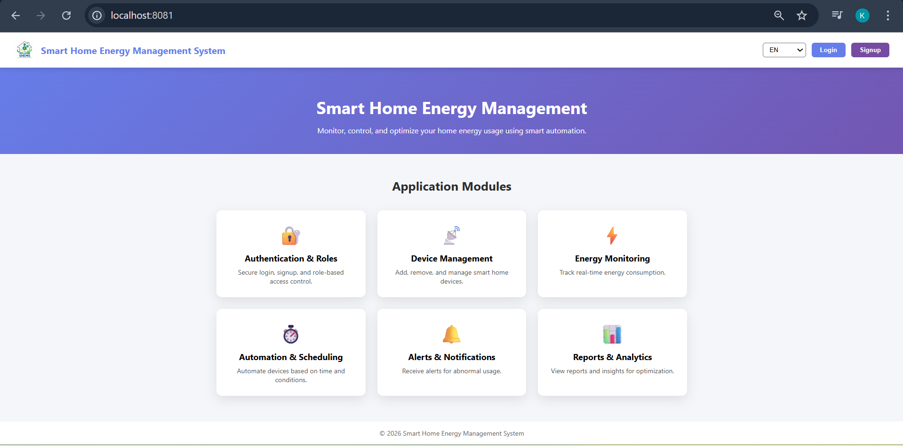

- Registration Page

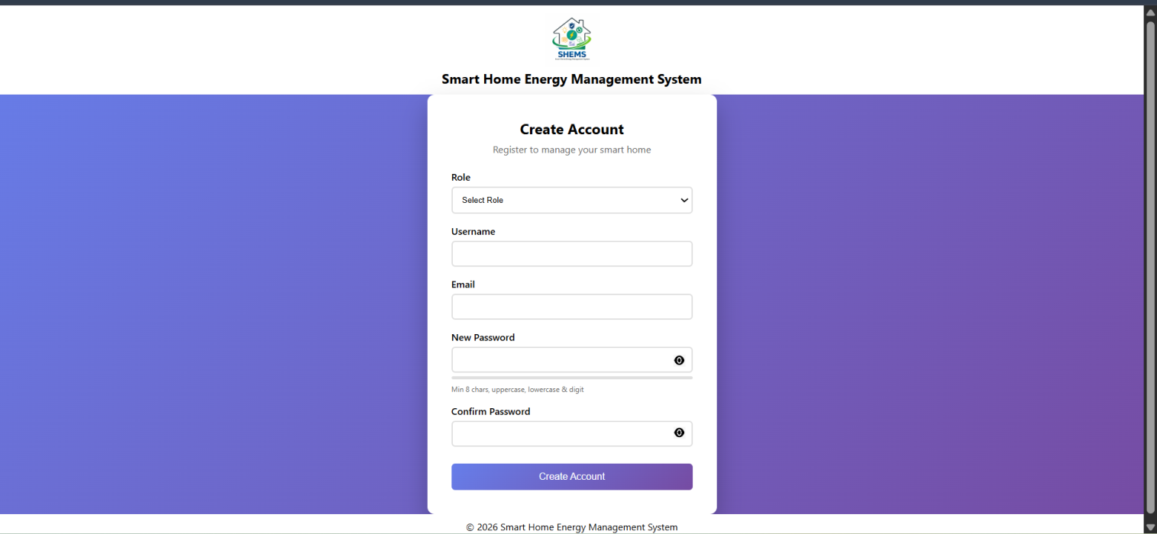

- Login Page

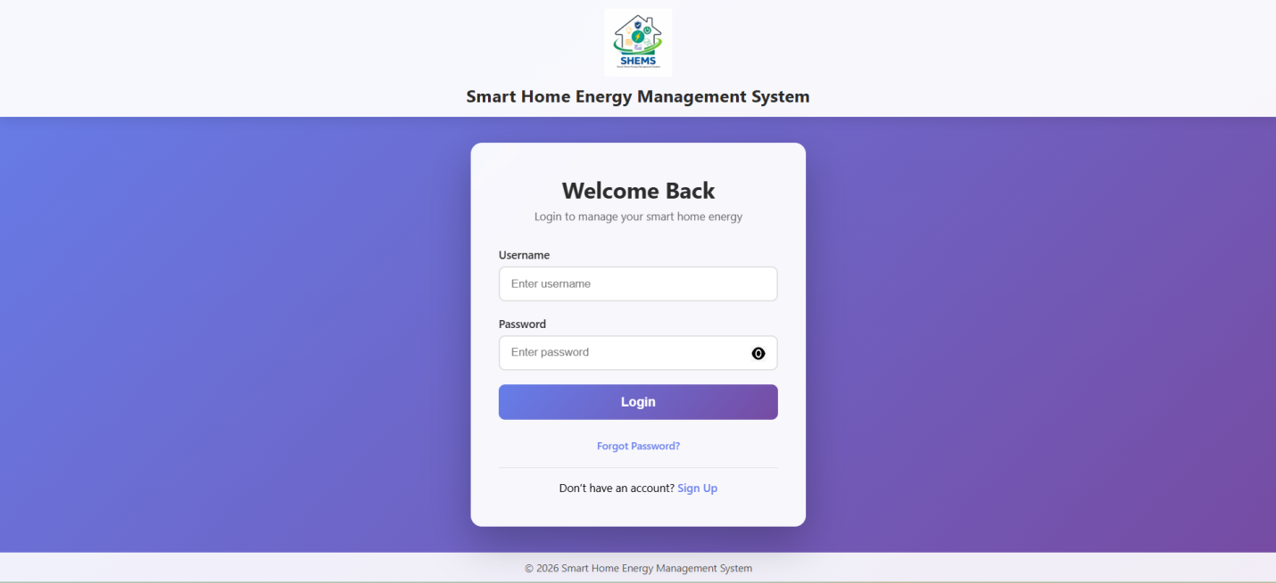

- Dashboard

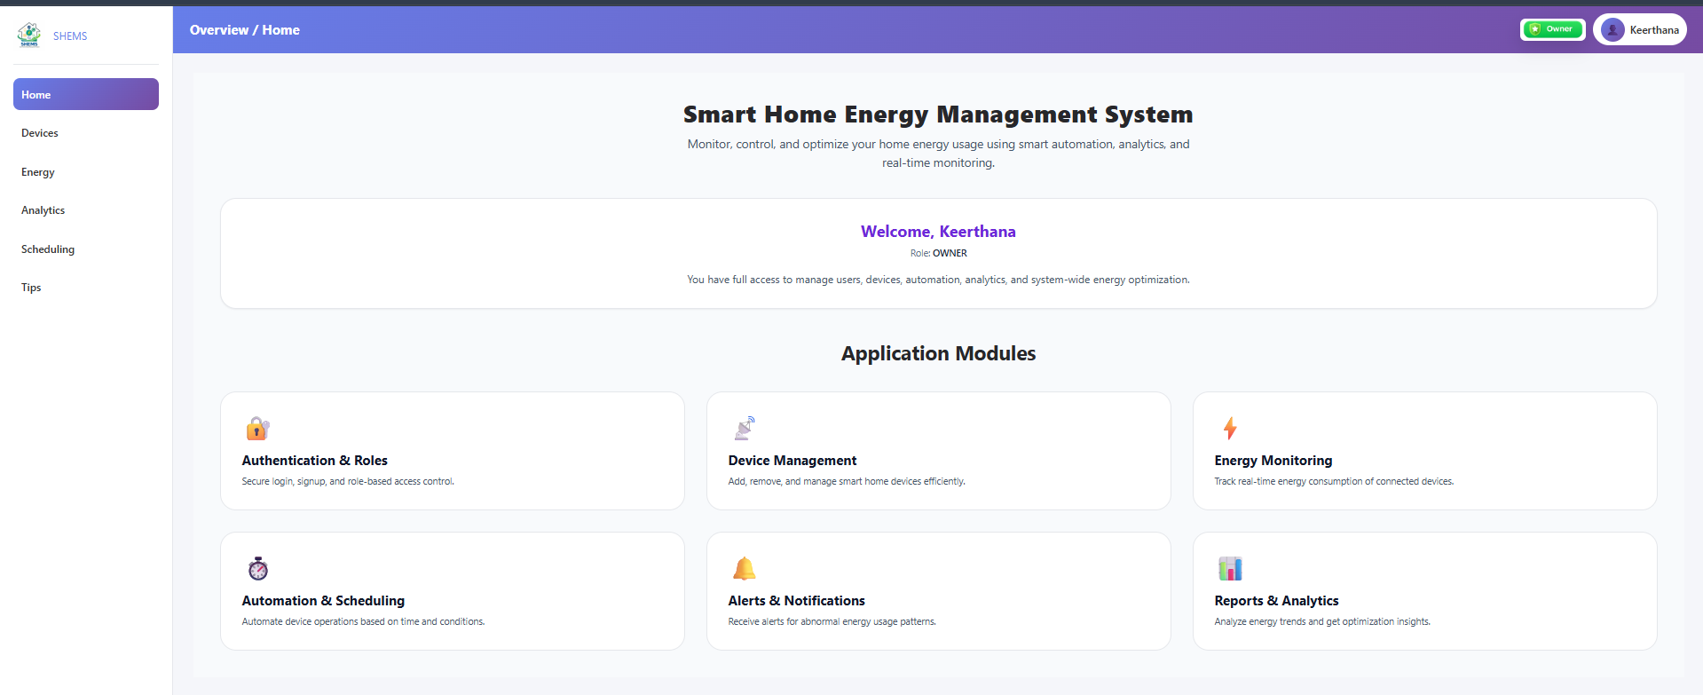

- Device Management Dashboard

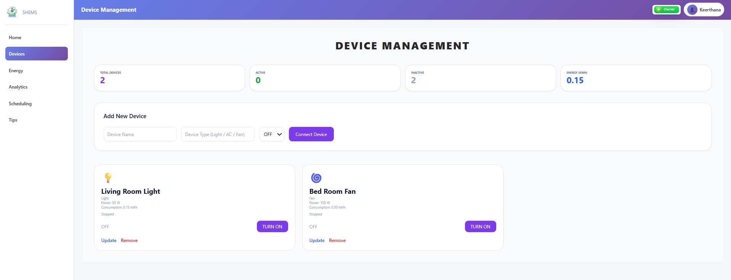

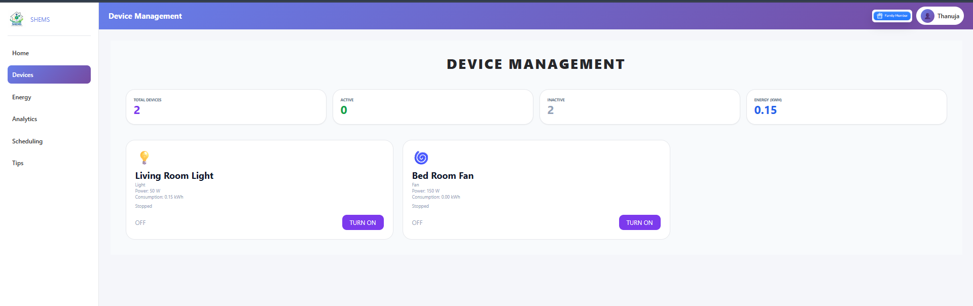

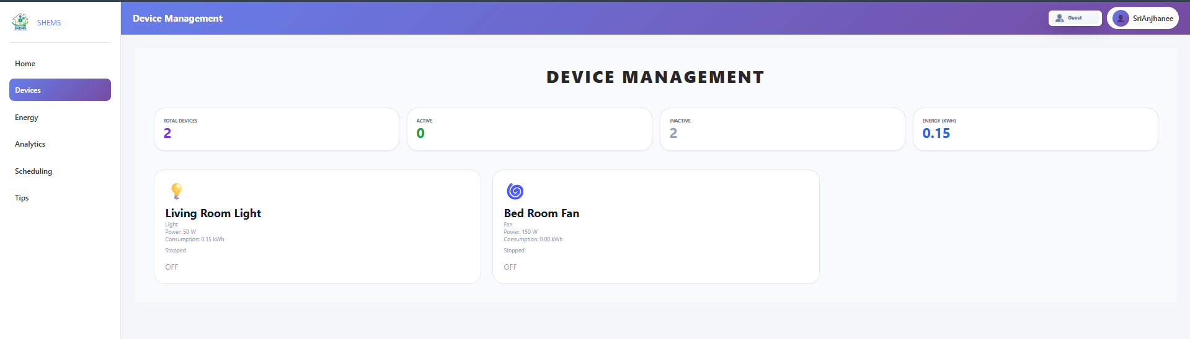

- Challenges Faced (Module 1 & Module 2)

Challenge 1: Secure User Authentication
Problem: Multiple users accessing the system without proper identity separation can lead to unauthorized actions and security risks.
Solution: Implemented individual user accounts with login validation and role-based access control to ensure secure system entry.

Challenge 2: Role-Based Access Management
Problem: Different users (Admin, Family Member, Guest) require different permissions, but improper role handling can expose critical controls.
Solution: Defined strict role rules where each role is allowed to access only permitted features, preventing misuse of sensitive operations.

Challenge 3: Preventing Guest Misuse
Problem: Guests controlling critical devices such as ACs, heaters, or security systems can compromise safety and energy efficiency.
Solution: Restricted guest access to non-critical devices and enforced time-limited permissions.

Challenge 4: Consistent Smart Device Registration
Problem: Improper device registration can result in duplicate entries, invalid devices, or incorrect ownership mapping.
Solution: Implemented device validation rules and linked each device to a specific authenticated user.

Challenge 5: Device Control Conflicts
Problem: Multiple users attempting to control the same device can cause inconsistent device states.
Solution: Centralized device control logic in the service layer to maintain a single source of truth for device status.

Challenge 6: Authentication–Device Module Integration
Problem: Allowing device control without verifying user authentication can break system security.
Solution: Integrated Module 1 and Module 2 such that device operations are accessible only after successful login.

- Conclusion
The Smart Home Energy Management System (SHEMS) project successfully achieved its primary objective of designing and implementing a secure, scalable, and modular smart home application. Through a structured milestone-driven approach, the team developed core functionalities such as user authentication, role-based access control, and smart device management using Java Spring Boot and MySQL.
The project demonstrated how modern software engineering practices can be applied to solve real-world problems related to energy monitoring and optimization. By following a layered architecture and secure development principles, the system ensures maintainability, extensibility, and protection against unauthorized access.
This internship provided valuable exposure to backend development, system architecture design, database integration, and collaborative development workflows. The experience not only strengthened technical skills but also improved teamwork, communication, and problem-solving abilities. Overall, SHEMS lays a strong foundation for future enhancements such as real-time energy analytics, automation rules, alerts, and mobile integration, making it a meaningful and practical learning experience.

